FULL STACK PROJECT REPORT

**On**

**Tourism Website Frontend**

**Submitted by**

**Vivek Singhal (171500395)**

**Divyansh Arya (171500103)**

**Ashutosh Anand (171500064)**

Under the supervision of

**Pankaj Kapoor**

Department of Computer Engineering & Applications

**Institute of Engineering & Technology**



**GLA University**

**Mathura- 281406, INDIA**

**2019**

Acknowledgement

We thank the almighty for giving us the courage and perseverance in completing the project.

This project itself is acknowledgements for all those people who have give us their heartfelt co-operation in making this project a grand success.

We extend our sincere thanks to ***Mr. Pankaj Kapoor*** Full Stack Trainer at GLA University, Mathura for providing valuable guidance at every stage of this project work. We are profoundly grateful towards the unmatched services rendered by him.

Last but not least , we would like to express our deep sense of gratitude and earnest thanks giving to our dear parents for their moral support and heartfelt cooperation in doing the main project.

Abstract

Tours and Travel website is a complete tourist fully integrated tourism website. The website covers all the areas required for an including tourism. The project is developed to manage the tourist in the tourist management website. The main module in this project are tour module, login module, customer module, travel module. Tours and Travel website gives you facility of booking any type of Tours and Travels. This system is made so that Customer will not have to come to us to Book his\her Tours. The project ‘Tours and Travel Website ‘ is developed to replace the currently existing system, which helps in keeping records of the customer, details of destination as well as payment received. In the present era where “time” proves to be the most important asset for an individual by replacing the current register system to fully computerize, it not only saves the precious asset that is time, but also accuracy, reliability and uniformity can be maintained. This project is useful for the manager of the company as it helps them to search the data faster than existing system, to get customer record easily and report of the customer, payment, etc are generated as per requirement.

Contents

Acknowledgement i

Abstract ii

1. Introduction 1

1.1 **Introduction** 1

1.2 **Motivation and Objective** 1

2. Software Requirement Analysis 2

**2.1** **Web Browser:** 2

**2.2** **Brackets:** 2

**2.2** **Modules and their functionality**: 2

3. User Interface 4

3.1 Main Page: 4

4. Conclusion 12

5. Bibliography 13

6. Appendix 14

**1. Introduction**

* 1. **Introduction**

The project is a tourism website that offers various tour packages to different tourist destinations across the world. Destinations are also categorised in different categories like : places for kids, couples ,family holiday , adventure trip ,hiking destinations etc. Each destination has its own information card displaying a picture of the place with some text with it. It is a hyperlinked card which when clicked will take the user to a different webpage which contains detailed information about that destination.

1.2 **Motivation and Objective**

Our motivation has been the increased interest of people wanting to travel to different parts of the world. Many people want to travel the world and want to make their stay and travel special , said that many are afraid that if they do not plan their tour properly they might miss out on some exiting and interesting things. So we came up with the idea of providing a fully planned tour and trips to people so that they don’t have to spend weeks and months just to make their holiday/visit memorable. Travel Monkey aims to provide the best in class services and tour packages to its customers so that they can enjoy every moment of their travel.

**2. Software Requirement Analysis**

**2.1** **Web Browser:**

A web browser, or simply "browser," is an application used to access and view websites. Common web browsers include Microsoft Internet Explorer, Google Chrome, Mozilla Firefox, and Apple Safari.

The primary function of a web browser is to render HTML, the code used to design or "mark up" web pages. Each time a browser loads a web page, it processes the HTML, which may include text, links, and references to images and other items, such as cascading style sheets and JavaScript functions. The browser processes these items, then, renders them in the browser window.

**2.2** **Brackets:**

Brackets is a source code editor with a primary focus on web development. Created by Adobe Systems, it is free and open-source software licensed under the MIT License, and is currently maintained on GitHub by Adobe and other open-source developers. It is written in JavaScript, HTML and CSS. Brackets is cross-platform, available for macOS, Windows, and most Linux distributions. The main purpose of brackets is its live HTML, CSS and JavaScript editing functionality.

**2.2** **Modules and their functionality**:

**2.2.1 Home Page Module:** The home page is the default page which will be loaded first for each person visiting the website. It contains navigaion bar on the top with brand name and various other hyperlinks on it and two links for sign up and login as well. It is fixed nav bar. Below the navbar, there is a slideshow of slides of various destinations. Following is an image grid of various places to visit and in the last there is a footer containing information about developers and links to their social media.

**2.2.2 Destination Module:** This module contains information about various places for visiting. Like Paris, London, Rome etc. Clicking a destinations card will redirect you to another page which contains more information about it. Then there are three tabs named ‘About’, ‘Photos’, ‘Places to Visit’ (popular landmarks of that destination). Destination page tells about the best things of that place.

**2.2.3 Sign Up Module:** The Sign Up section comes when clicked on the Sign Up Button given in the navigation bar at the top ,a little of animation is used to show the contents of Sign Up . User gets certain benefits when signing in as then only user can book the tours package.

**2.2.4 Login Module:** Login Form comes when user clicks on the Login Button in the navigation bar and only those users who have previously signed in can only Login as there given credentials are stored in the database and for the rest, will show error.

On entering the correct username and password, user is logged in and he/she can verify this by checking their username on the front page of website.

**2.2.5 Loader Module:** This module is used to show the loading screen while the page is being load. Loading Screen consists of four different colored dots jumping in a repeated pattern.

**3. User Interface**

## 3.1 Main Page:

The main page which will be visible to every visiting person and this contains all the other sections directly or indirectly.

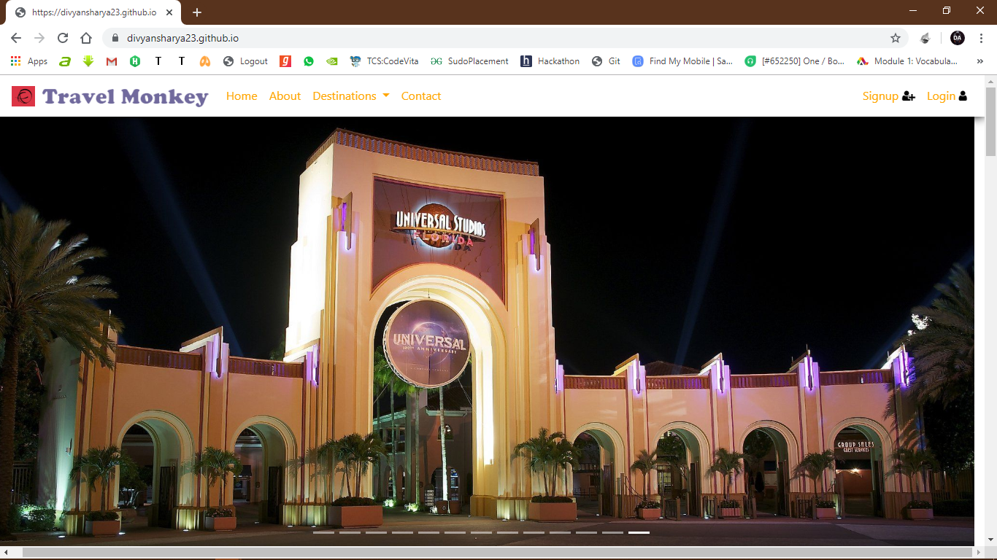

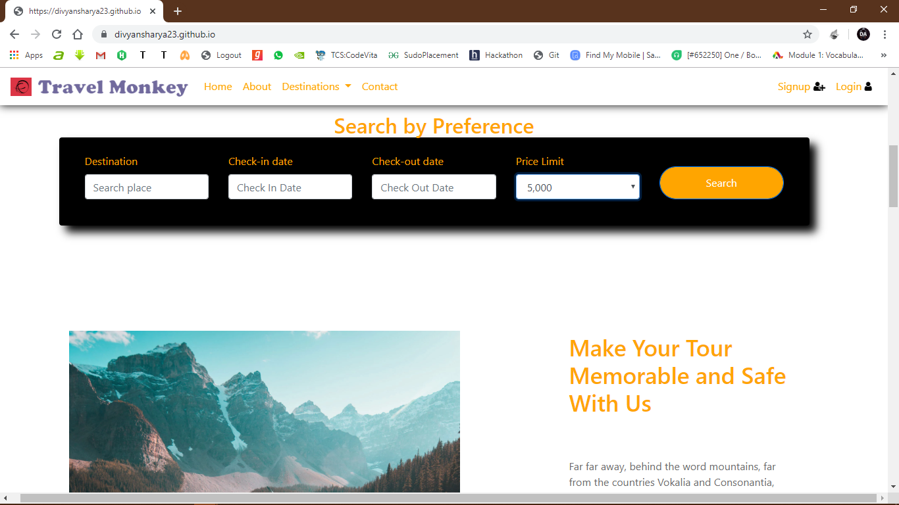

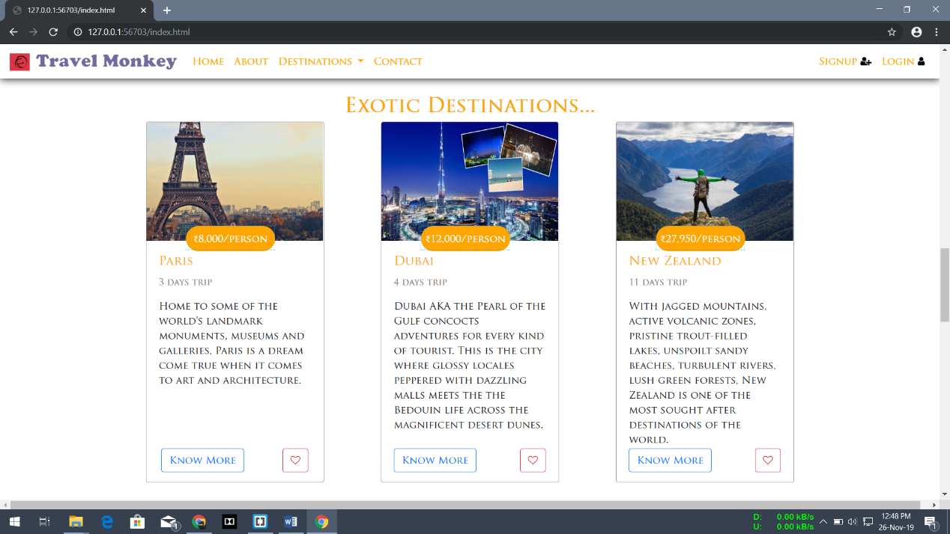

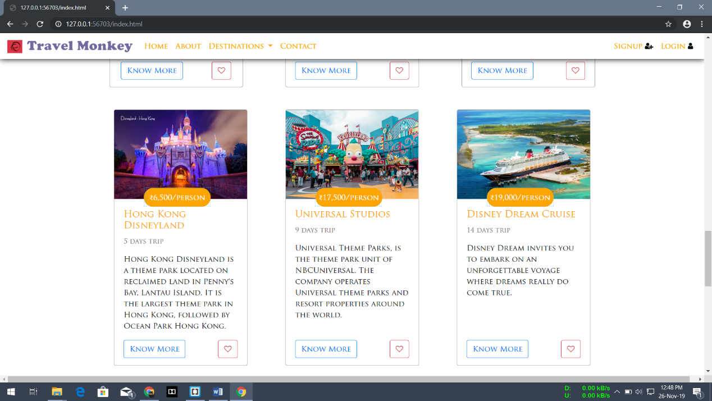

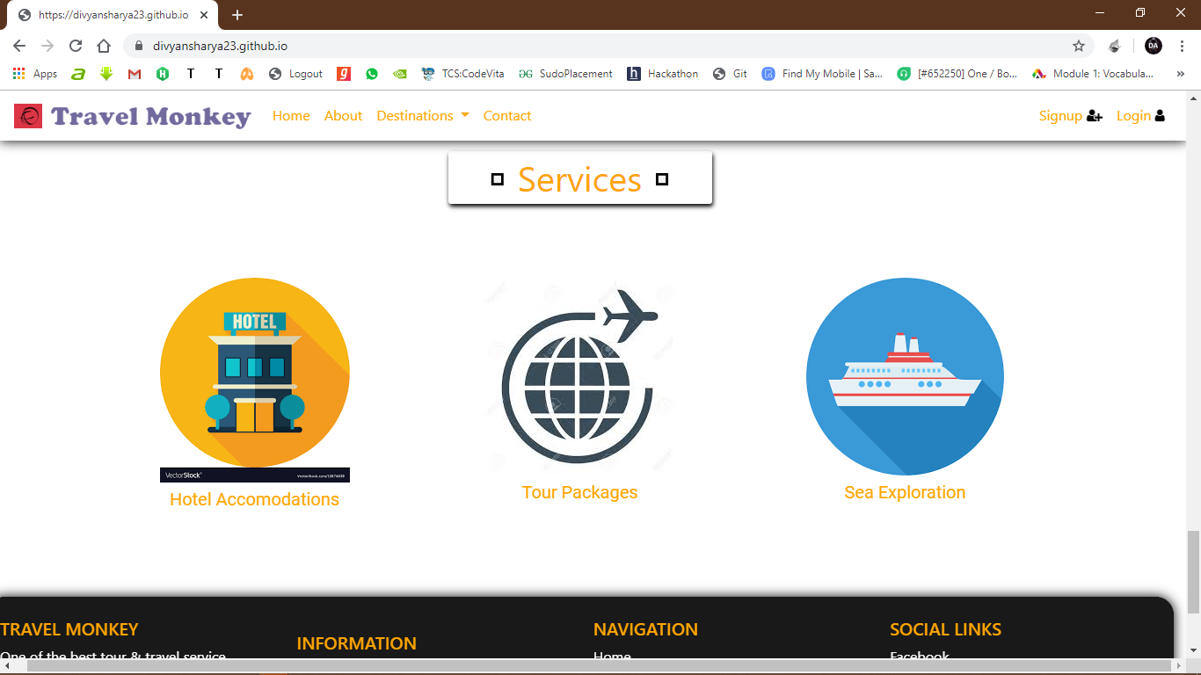

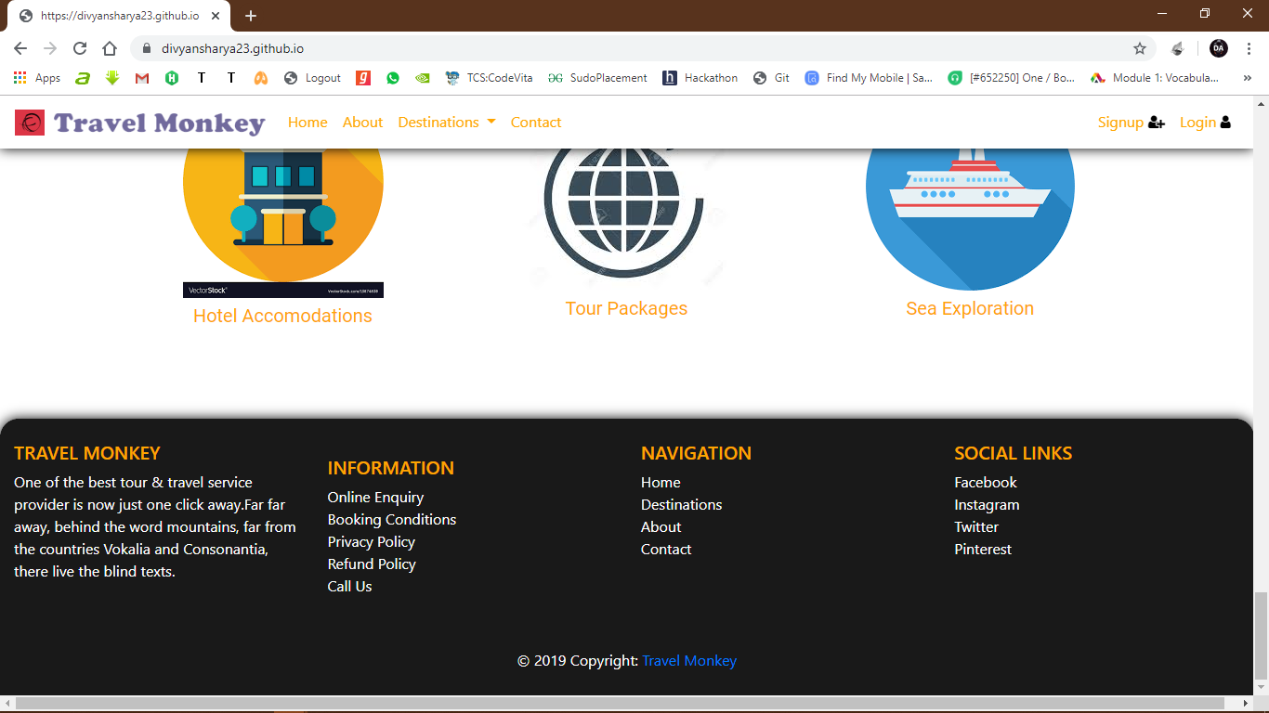

**3.2 Destinations:**

**3.2.1 Paris:**

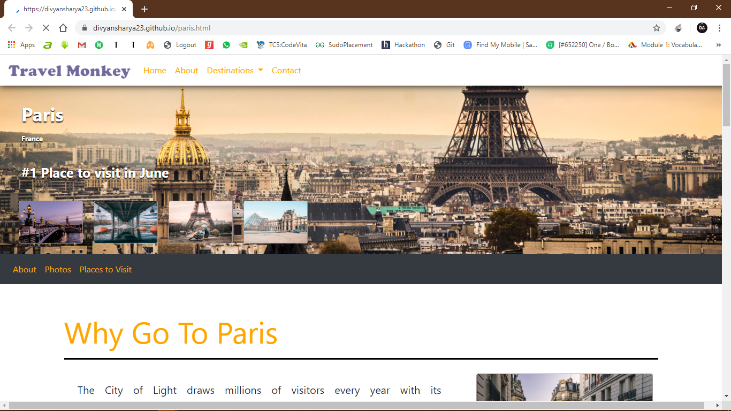

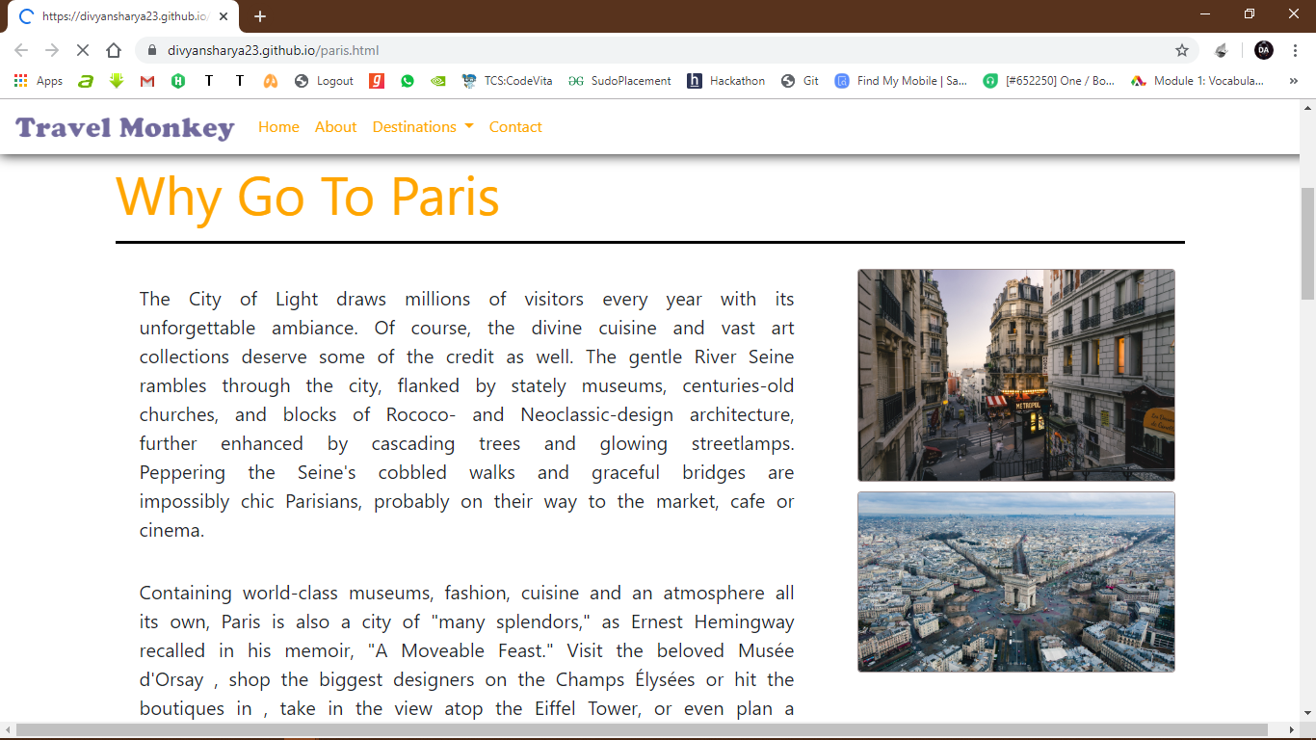

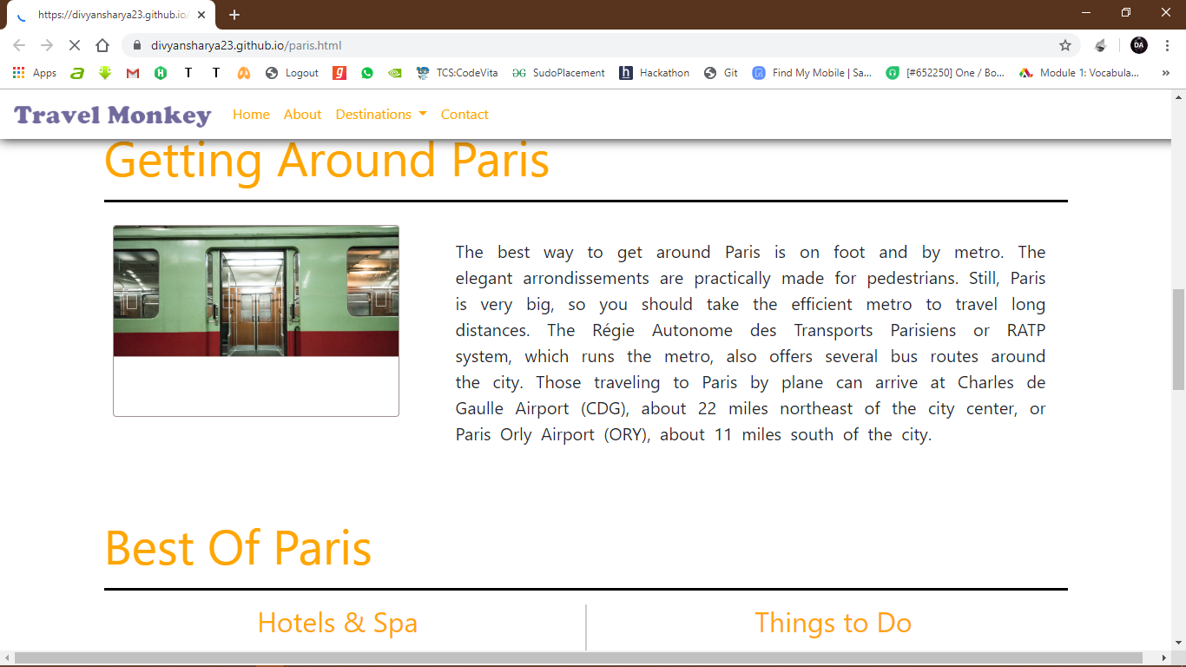

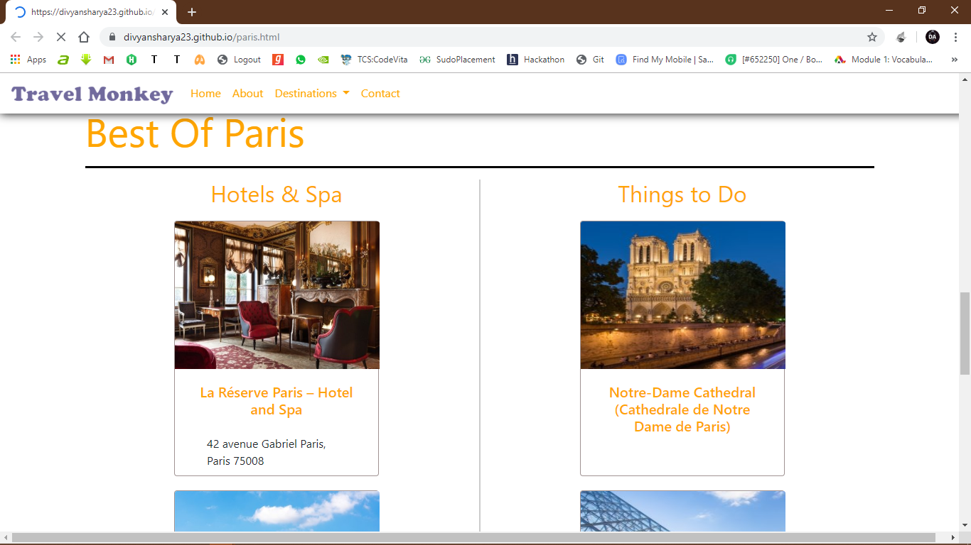

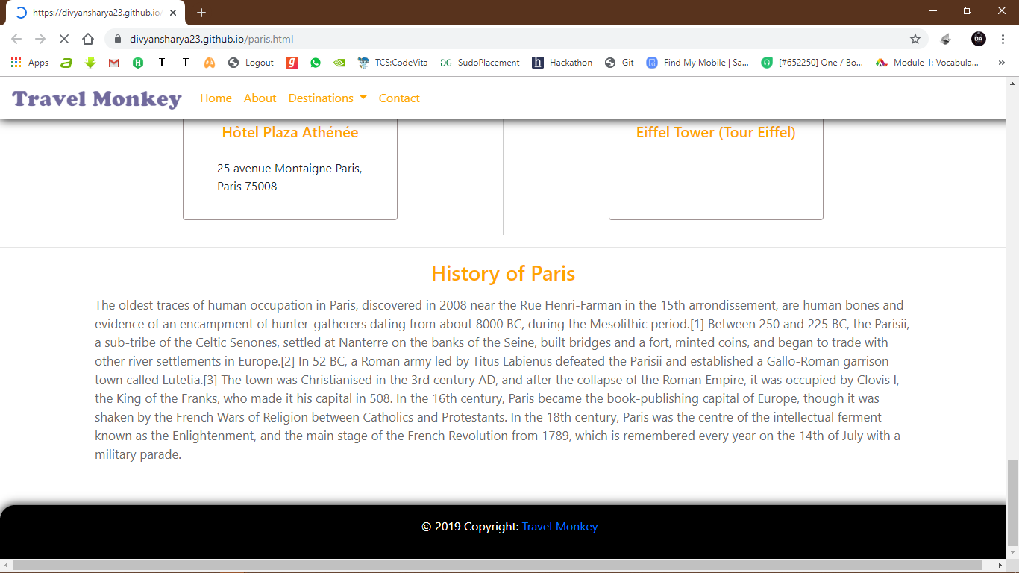

**3.2.2 HongKong, Disneyland**

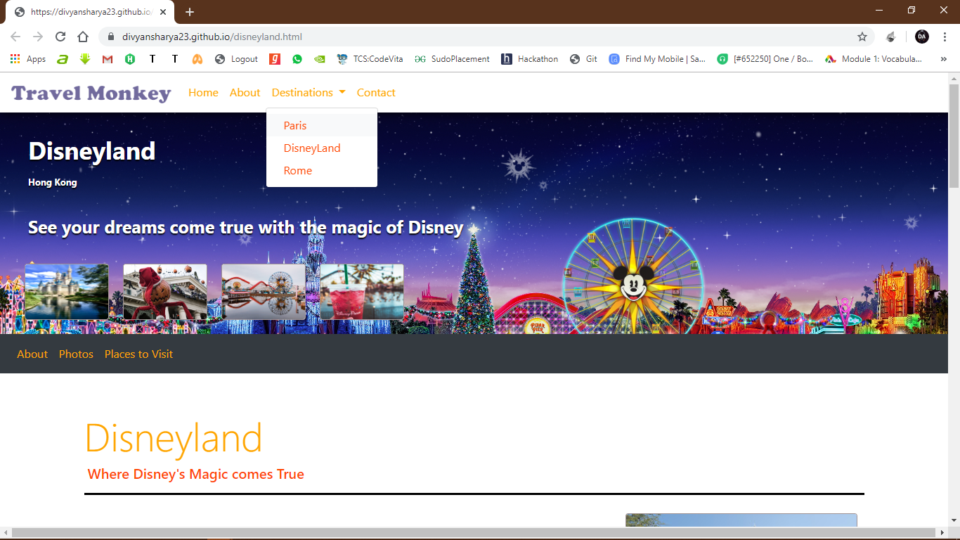

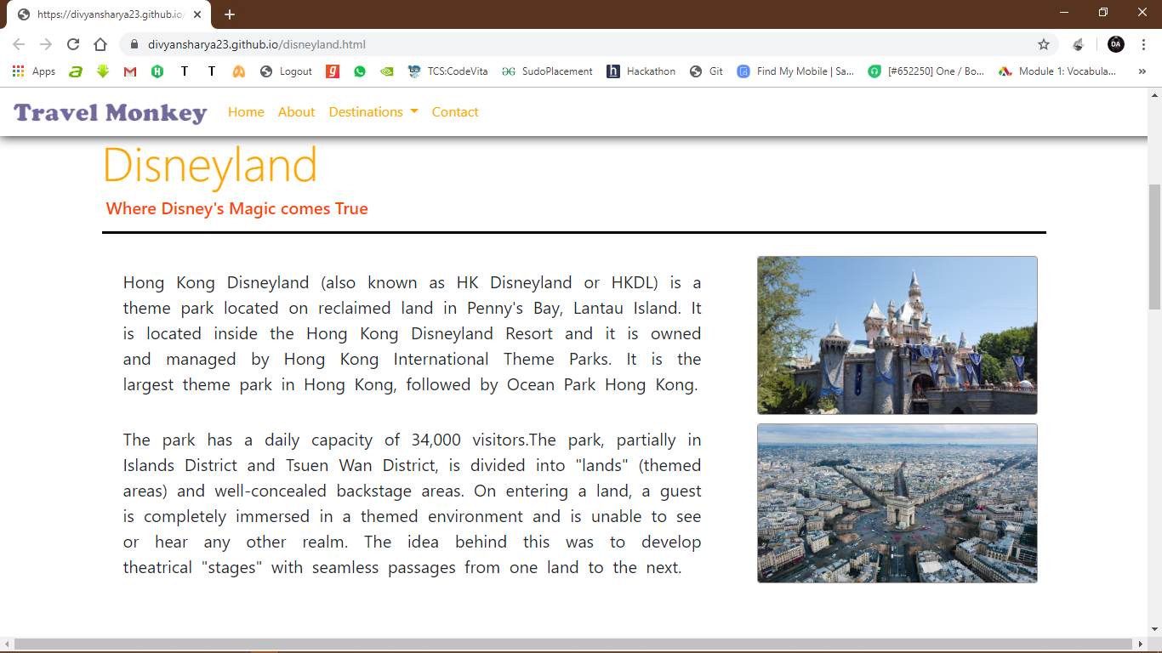

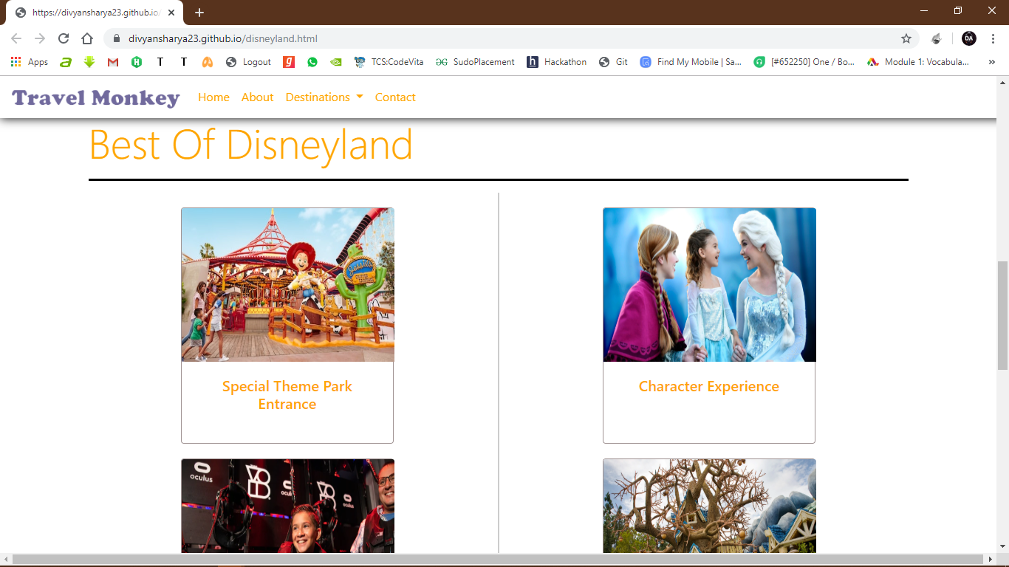

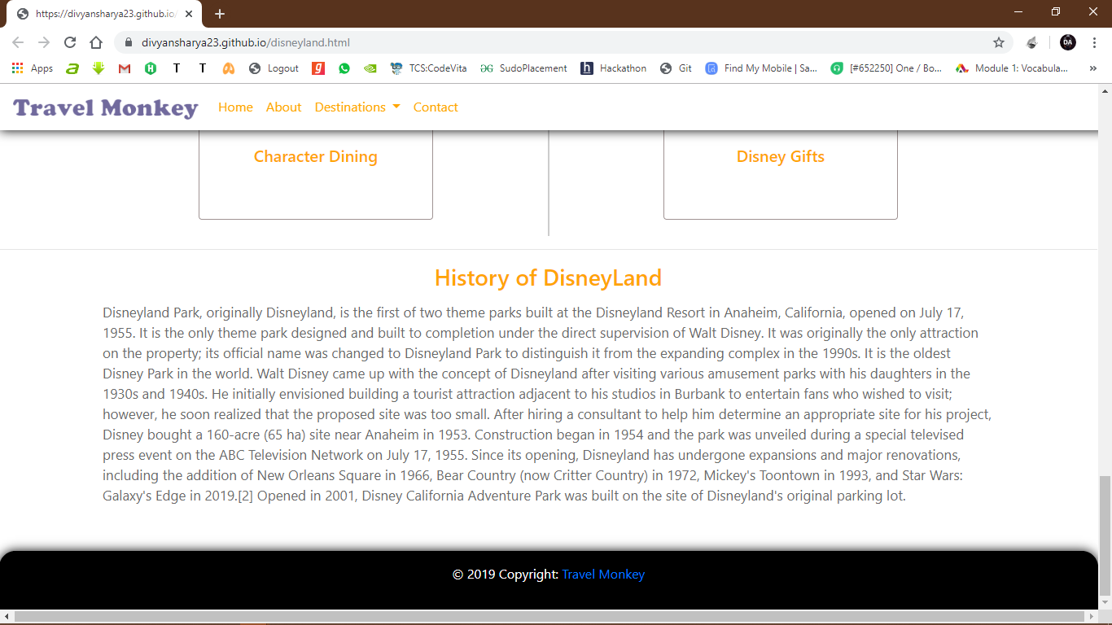

**4. Conclusion**

Tourism is currently recognized as a global industry which is highly growing at a high rate, and like any industry that grows rapidly, the activities of tourism can have a substantial impact on the local development processes. Tours and Travel Website simplifies the management process in travelling. It gives fast processing and immediate results with high security. Navigation through site is easy. It minimizes human effort and is cost efficient. The website automates the processes and activities of a travel agency. In the present system a customer has to approach various agencies to find details of places and to book tickets. This often requires a lot of time and effort. We provide approach skills to critically examine how a tourist visits and its ability to operate in an appropriate way when dealing with the consequences of tourism, locally, regionally, and nationally including visitor security and ecological influences.

**5. Bibliography**

[1] https://stackoverflow.com/

[2] https://www.w3schools.com/bootstrap/

[3] https://travel.usnews.com/

[4] https://getbootstrap.com/

**6. Appendix**

<!DOCTYPE html>

<html lang="en">

<head>

<meta charset="utf-8">

<meta name="viewport" content="width=device-width, initial-scale=1.0">

<title></title>

<link href="https://fonts.googleapis.com/css?family=Calistoga|Roboto&display=swap" rel="stylesheet">

<link href="https://stackpath.bootstrapcdn.com/bootstrap/4.3.1/css/bootstrap.min.css" rel="stylesheet" integrity="sha384-ggOyR0iXCbMQv3Xipma34MD+dH/1fQ784/j6cY/iJTQUOhcWr7x9JvoRxT2MZw1T" crossorigin="anonymous">

<title>Welcome to Travel Monkey</title>

<link rel="stylesheet" href="https://stackpath.bootstrapcdn.com/font-awesome/4.7.0/css/font-awesome.min.css">

<link rel="stylesheet" href="css/index.css">

</head>

<body onload="meraFunc()">

<div id="loading" style="position: fixed;width: 100%;height: 100vh;z-index: 99;background: white url('lgloader.gif') no-repeat center;">

</div>

<nav class="navbar navbar-expand-lg bg-info fixed-top navbar-light" id="navclas" style="visibility: hidden">

<a class="navbar-brand" href="#">

<i class="fa fa-ravelry mr-1 p-1 bg-danger" aria-hidden="true"></i>

<img src="images/logo/logo.png" height="25px" style="">

</a>

<button class="navbar-toggler" type="button" data-toggle="collapse" data-target="#navbarSupportedContent" aria-controls="navbarSupportedContent" aria-expanded="false" aria-label="Toggle navigation">

<span class="navbar-toggler-icon"></span>

</button>

<div class="collapse navbar-collapse align-items-center justify-content-center" id="navbarSupportedContent">

<ul class="navbar-nav mr-auto">

<li class="nav-item active">

<a class="nav-link" href="index.html" style="color: orange">Home <span class="sr-only">(current)</span></a>

</li>

<li class="nav-item">

<a class="nav-link" href="#" style="color: orange">About</a>

</li>

<li class="nav-item dropdown">

<a class="nav-link dropdown-toggle" href="#" id="navbarDropdown" role="button" data-toggle="dropdown" aria-haspopup="true" aria-expanded="false" style="color: orange">

Destinations

</a>

<div class="dropdown-menu" aria-labelledby="navbarDropdown">

<a class="dropdown-item" href="paris.html" style="color: orangered">Paris</a>

<a class="dropdown-item" href="disneyland.html" style="color: orangered">DisneyLand</a>

<!-- <div class="dropdown-divider"></div>-->

<a class="dropdown-item" href="#" style="color: orangered">Rome</a>

</div>

</li>

<li class="nav-item">

<a class="nav-link" href="#" style="color: orange">Contact</a>

</li>

</ul>

<ul class="navbar-nav">

<li class="nav-item">

<a class="nav-link" href="#" style="color: orange">Signup <i class="fa fa-user-plus" style="color: black;"></i></a>

</li>

<li class="nav-item">

<a class="nav-link" href="#" style="color: orange">Login <i class="fa fa-user" style="color: black;"></i></a>

</li>

</ul>

</div>

</nav>

<div class="row" style="padding-top: 20px;">

<div class="container-fluid col-md-12 topslider">

<div id="demo" class="carousel slide" data-ride="carousel" data-interval="2500" data-pause="false" style="background-size: cover;">

<!-- Indicators -->

<ul class="carousel-indicators" id="carousel-indicators">

<li data-target="#demo" data-slide-to="0" class="active"></li>

<li data-target="#demo" data-slide-to="1"></li>

<li data-target="#demo" data-slide-to="2"></li>

<li data-target="#demo" data-slide-to="3"></li>

<li data-target="#demo" data-slide-to="4"></li>

<li data-target="#demo" data-slide-to="5"></li>

<li data-target="#demo" data-slide-to="6"></li>

<li data-target="#demo" data-slide-to="7"></li>

<li data-target="#demo" data-slide-to="8"></li>

<li data-target="#demo" data-slide-to="9"></li>

<li data-target="#demo" data-slide-to="10"></li>

<li data-target="#demo" data-slide-to="11"></li>

<li data-target="#demo" data-slide-to="12"></li>

</ul>

<!-- The slideshow -->

<div class="carousel-inner" style="max-height: 95.8vh;width: 98.8vw !important;">

<div class="carousel-item active">

<img src="images/carousel/0dubai_%20newedit.jpg" alt="Tv image">

</div>

<div class="carousel-item">

<img src="images/carousel/1Dubai_03.jpg" alt="Tv image">

</div>

<div class="carousel-item">

<img src="images/carousel/2Dubai_04.jpg" alt="Laptop">

</div>

<div class="carousel-item">

<img src="images/carousel/3Dubai_05.jpg" alt="Laptop">

</div>

<div class="carousel-item">

<img src="images/carousel/4Hong%20Kong_01.jpg" alt="Laptop">

</div>

<div class="carousel-item">

<img src="images/carousel/5Hong%20Kong_03.jpg" alt="Laptop">

</div>

<div class="carousel-item">

<img src="images/carousel/6Hong%20Kong_05.jpg" alt="Laptop">

</div>

<div class="carousel-item">

<img src="images/carousel/7london.jpg">

</div>

<div class="carousel-item">

<img src="images/carousel/8New%20Zealand_01.jpg">

</div>

<div class="carousel-item">

<img src="images/carousel/9New%20Zealand_03.jpg" alt="Laptop">

</div>

<div class="carousel-item">

<img src="images/carousel/12Paris_03.jpg" alt="Laptop">

</div>

<div class="carousel-item">

<img src="images/carousel/13Universal_02.jpg" alt="Laptop">

</div>

<div class="carousel-item">

<img src="images/carousel/14Universal_04.jpg" alt="Laptop">

</div>

</div>

</div>

</div>

</div>

<center>

<h2 style="position: relative;top: 7rem;color: orange;font-weight: 600">Search by Preference</h2>

</center>

<div class="container" id="seardest">

<div class="row">

<div class="col-md-12">

<div class="search-wrap-1 ftco-animate p-4 fadeInUp ftco-animated">

<form action="#" class="search-property-1">

<div class="row">

<div class="col-lg align-items-end">

<div class="form-group">

<label for="#">Destination</label>

<div class="form-field">

<div class="icon"><span class="ion-ios-search"></span></div>

<input type="text" class="form-control" placeholder="Search place">

</div>

</div>

</div>

<div class="col-lg align-items-end">

<div class="form-group">

<label for="#">Check-in date</label>

<div class="form-field">

<div class="icon"><span class="ion-ios-calendar"></span></div>

<input type="text" class="form-control checkin_date" placeholder="Check In Date">

</div>

</div>

</div>

<div class="col-lg align-items-end">

<div class="form-group">

<label for="#">Check-out date</label>

<div class="form-field">

<div class="icon"><span class="ion-ios-calendar"></span></div>

<input type="text" class="form-control checkout_date" placeholder="Check Out Date">

</div>

</div>

</div>

<div class="col-lg align-items-end">

<div class="form-group">

<label for="#">Price Limit</label>

<div class="form-field">

<div class="select-wrap">

<div class="icon"><span class="ion-ios-arrow-down"></span></div>

<select name="" id="" class="form-control">

<option value="">5,000</option>

<option value="">10,000</option>

<option value="">50,000</option>

<option value="">100,000</option>

<option value="">200,000</option>

<option value="">300,000</option>

</select>

</div>

</div>

</div>

</div>

<div class="col-lg align-self-end">

<div class="form-group">

<div class="form-field">

<input type="submit" value="Search" class="form-control btn btn-primary" style="background-color: orange;border-radius: 30px;height: 50px;">

</div>

</div>

</div>

</div>

</form>

</div>

</div>

</div>

</div>

<div class="container" style="margin-bottom: 15rem;margin-top: 10rem">

<div class="row justify-content-around mb-2">

<div class="col-lg-4">

<img src="/images/boat.png" alt="Boat" style="background-size: cover">

</div>

<div class="col-lg-4"></div>

<div class="col-lg-4" style="padding-left: -3rem">

<h2 style="font-size: 35px; font-weight: 500;padding-top: 0.25rem;color: orange">Make Your Tour Memorable and Safe With Us</h2>

<p style="color: dimgray;padding-top: 3.5rem;">Far far away, behind the word mountains, far from the countries Vokalia and Consonantia, there live the blind texts. Separated they live in Bookmarksgrove right at the coast of the Semantics, a large language ocean.</p>

<img src="/images/nos.png" alt="Numbers" style="width: 24rem;padding-top: 3.5rem;">

</div>

</div>

</div>

<div class="container mt-5">

<center>

<h2 style="top: 0rem;color: orange;font-weight: 600">Exotic Destinations...</h2>

</center>

<div class="row justify-content-around mb-3">

<div class="card" style="width: 18rem;height: 34.5rem">

<img src="images/destcards/effel_edit.jpg" class="card-img-top" alt="Img" style="background: cover;height: 12rem">

<div class="card-body">

<h5 class="card-title" style="color: orange">Paris</h5>

<p class="card-text">Home to some of the world’s landmark monuments, museums and galleries, Paris is a dream come true when it comes to art and architecture. </p>

<a href="paris.html" class="btn btn-outline-primary" style="position: absolute;bottom: 1rem">Know More</a>

<a href="#" class="btn btn-outline-danger" data-toggle="tooltip" title="Add to Bucket" style="position: absolute;left: 14rem;bottom: 1rem;"><i class="fa fa-heart-o" aria-hidden="true"></i></a>

</div>

</div>

<div class="card" style="width: 18rem;height: 34.5rem">

<img src="images/destcards/dubai_%20newedit.jpg" class="card-img-top" alt="Img" style="background: cover;height: 12rem">

<div class="card-body">

<h5 class="card-title" style="color: orange">Dubai</h5>

<p class="card-text">Dubai AKA the Pearl of the Gulf concocts adventures for every kind of tourist. This is the city where glossy locales peppered with dazzling malls meets the the Bedouin life across the magnificent desert dunes.</p>

<a href="#" class="btn btn-outline-primary" style="position: absolute;bottom: 1rem;">Know More</a>

<a href="#" class="btn btn-outline-danger" data-toggle="tooltip" title="Add to Bucket" style="position: absolute;left: 14rem; bottom:1rem;"><i class="fa fa-heart-o" aria-hidden="true"></i></a>

</div>

</div>

<div class="card" style="width: 18rem;height: 34.5rem">

<img src="images/destcards/newzealand.jpg" class="card-img-top" alt="Img" style="background: cover;height: 12rem">

<div class="card-body">

<h5 class="card-title" style="color: orange">New Zealand</h5>

<p class="card-text">With jagged mountains, active volcanic zones, pristine trout-filled lakes, unspoilt sandy beaches, turbulent rivers, lush green forests, New Zealand is one of the most sought after destinations of the world.</p>

<a href="#" class="btn btn-outline-primary" style="position: absolute;bottom: 1rem;">Know More</a>

<a href="#" class="btn btn-outline-danger" data-toggle="tooltip" title="Add to Bucket" style="position: absolute;left: 14rem; bottom:1rem;"><i class="fa fa-heart-o" aria-hidden="true"></i></a>

</div>

</div>

</div>

<div class="container mt-5">

<div class="row justify-content-around mb-3">

<div class="card" style="width: 18rem;height: 34.5rem">

<img src="images/destcards/disneyland.jpg" class="card-img-top" alt="Img" style="background: cover;height: 12rem">

<div class="card-body">

<h5 class="card-title" style="color: orange">Hong Kong Disneyland</h5>

<p class="card-text">Hong Kong Disneyland is a theme park located on reclaimed land in Penny's Bay, Lantau Island. It is the largest theme park in Hong Kong, followed by Ocean Park Hong Kong.</p>

<a href="disneyland.html" class="btn btn-outline-primary" style="position: absolute;bottom: 1rem;">Know More</a>

<a href="#" class="btn btn-outline-danger" data-toggle="tooltip" title="Add to Bucket" style="position: absolute;left: 14rem; bottom:1rem;"><i class="fa fa-heart-o" aria-hidden="true"></i></a>

</div>

</div>

<div class="card" style="width: 18rem;height: 34.5rem">

<img src="images/destcards/UniversalSrudio.jpg" class="card-img-top" alt="Img" style="background: cover;height: 12rem">

<div class="card-body">

<h5 class="card-title" style="color: orange">Universal Studios</h5>

<p class="card-text">Universal Theme Parks, is the theme park unit of NBCUniversal. The company operates Universal theme parks and resort properties around the world.</p>

<a href="#" class="btn btn-outline-primary" style="position: absolute;bottom: 1rem;">Know More</a>

<a href="#" class="btn btn-outline-danger" data-toggle="tooltip" title="Add to Bucket" style="position: absolute;left: 14rem; bottom:1rem;"><i class="fa fa-heart-o" aria-hidden="true"></i></a>

</div>

</div>

<div class="card" style="width: 18rem;height: 34.5rem">

<img src="images/destcards/disney-dream-cruise.jpg" class="card-img-top" alt="Img" style="background: cover;height: 12rem">

<div class="card-body">

<h5 class="card-title" style="color: orange">Disney Dream Cruise</h5>

<p class="card-text">Disney Dream invites you to embark on an unforgettable voyage where dreams really do come true.</p>

<a href="#" class="btn btn-outline-primary" style="position: absolute;bottom: 1rem;">Know More</a>

<a href="#" class="btn btn-outline-danger" data-toggle="tooltip" title="Add to Bucket" style="position: absolute;left: 14rem; bottom:1rem;"><i class="fa fa-heart-o" aria-hidden="true"></i></a>

</div>

</div>

</div>

</div>

<div class="container" style="margin-top: 18rem">

<center>

<p class="text-center mt-5" style="font-size: 40px;width: 300px;box-shadow: 1px 3px 5px black;border-radius: 3px;color: orange">

◽ Services ◽

</p>

</center>

<div class="row justify-align-center" style="margin-top:80px;">

<div class="col-sm-6 col-lg-4 center-block text-center">

<img src="images/services/hotel.png" class="img-thumbnail" style="border: 0">

<p style="font-size: 20px; font-family: 'Roboto', sans-serif;color: orange">Hotel Accomodations</p>

</div>

<div class="col-sm-6 col-lg-4 center-block text-center">

<img src="images/services/tour.jfif" class="img-thumbnail" style="border: 0;">

<p style="font-size: 20px; font-family: 'Roboto', sans-serif;color: orange">Tour Packages</p>

</div>

<div class="col-sm-6 col-lg-4 center-block text-center">

<img src="images/services/cruise.png" class="img-thumbnail" style="border: 0;">

<p style="font-size: 20px; font-family: 'Roboto', sans-serif;color: orange">Sea Exploration</p>

</div>

</div>

</div>

</div>

<!-- Footer -->

<footer class="page-footer font-small blue pt-4" style="background-color: rgba(20, 39, 57,1);padding-bottom: 10px;color: white;border-radius: 20px 20px 0px 0px;margin-top: 80px;height: auto !important;">

<!-- Footer Links -->

<div class="container-fluid text-center text-md-left">

<!-- Grid row -->

<div class="row">

<!-- Grid column -->

<div class="col-md-3 mt-md-0 mt-3">

<!-- Content -->

<h5 class="text-uppercase" style="color: orange">Travel Monkey</h5>

<p>One of the best tour & travel service provider is now just one click away.Far far away, behind the word mountains, far from the countries Vokalia and Consonantia, there live the blind texts.</p>

</div>

<!-- Grid column -->

<!-- Grid column -->

<div class="col-md-3 mb-md-0 mt-3">

<!-- Links -->

<h5 class="text-uppercase" style="color: orange">Information</h5>

<ul class="list-unstyled">

<li>

<a href="#!">Online Enquiry</a>

</li>

<li>

<a href="#carousel-indicators">Booking Conditions</a>

</li>

<li>

<a href="#!">Privacy Policy</a>

</li>

<li>

<a href="#!">Refund Policy</a>

</li>

<li>

<a href="#!">Call Us</a>

</li>

</ul>

</div>

<!-- Grid column -->

<!-- Grid column -->

<div class="col-md-3 mb-md-0 mb-3">

<!-- Links -->

<h5 class="text-uppercase" style="color: orange">Navigation</h5>

<ul class="list-unstyled">

<li>

<a href="#!">Home</a>

</li>

<li>

<a href="#carousel-indicators">Destinations</a>

</li>

<li>

<a href="#!">About</a>

</li>

<li>

<a href="#!">Contact</a>

</li>

</ul>

</div>

<!-- Grid column -->

<!-- Grid column -->

<div class="col-md-3 mb-md-0 mb-3">

<!-- Links -->

<h5 class="text-uppercase" style="color: orange">Social Links</h5>

<ul class="list-unstyled">

<li>

<a href="#!">Facebook</a>

</li>

<li>

<a href="#!">Instagram</a>

</li>

<li>

<a href="#!">Twitter</a>

</li>

<li>

<a href="#!">Pinterest</a>

</li>

</ul>

</div>

<!-- Grid column -->

</div>

<!-- Grid row -->

</div>

<br>

<div class="footer-copyright text-center py-3">© 2019 Copyright:

<a href="index.html"> Travel Monkey</a>

</div>

</footer>

<!-- Footer -->

<script>

var pl = document.getElementById('loading');

var nc = document.getElementById('navclas');

function meraFunc() {

setTimeout(function() {

pl.style.display = "none";

nc.style.visibility = "visible";

}, 1600);

}

</script>

</body>

<script src="https://stackpath.bootstrapcdn.com/bootstrap/4.3.1/js/bootstrap.min.js" integrity="sha384-JjSmVgyd0p3pXB1rRibZUAYoIIy6OrQ6VrjIEaFf/nJGzIxFDsf4x0xIM+B07jRM" crossorigin="anonymous"></script>

<script src="https://stackpath.bootstrapcdn.com/bootstrap/4.3.1/js/bootstrap.bundle.min.js" integrity="sha384-xrRywqdh3PHs8keKZN+8zzc5TX0GRTLCcmivcbNJWm2rs5C8PRhcEn3czEjhAO9o" crossorigin="anonymous"></script>

<!-- jQuery first, then Popper.js, then Bootstrap JS -->

<script src="https://code.jquery.com/jquery-3.3.1.slim.min.js" integrity="sha384-q8i/X+965DzO0rT7abK41JStQIAqVgRVzpbzo5smXKp4YfRvH+8abtTE1Pi6jizo" crossorigin="anonymous"></script>

<script src="https://cdnjs.cloudflare.com/ajax/libs/popper.js/1.14.7/umd/popper.min.js" integrity="sha384-UO2eT0CpHqdSJQ6hJty5KVphtPhzWj9WO1clHTMGa3JDZwrnQq4sF86dIHNDz0W1" crossorigin="anonymous"></script>

<script src="https://stackpath.bootstrapcdn.com/bootstrap/4.3.1/js/bootstrap.min.js" integrity="sha384-JjSmVgyd0p3pXB1rRibZUAYoIIy6OrQ6VrjIEaFf/nJGzIxFDsf4x0xIM+B07jRM" crossorigin="anonymous"></script>

</html>